ГУАП

КАФЕДРА № 41

ОТЧЕТ   
ЗАЩИЩЕН С ОЦЕНКОЙ

ПРЕПОДАВАТЕЛЬ

|  |  |  |  |  |
| --- | --- | --- | --- | --- |
| Доцент, доцент |  |  |  | С. А. Чернышев |
| должность, уч. степень, звание |  | подпись, дата |  | инициалы, фамилия |

|  |
| --- |
| ОТЧЕТ О ПРАКТИЧЕСКОЙ РАБОТЕ №2 |
| «Проектирование навигации в GUI кроссплатформенных приложений» |
| по курсу: «Методы объектно-ориентированного проектирования» |
|  |
|  |

РАБОТУ ВЫПОЛНИЛ

|  |  |  |  |  |  |
| --- | --- | --- | --- | --- | --- |
| СТУДЕНТ гр. № |  |  |  |  |  |
|  |  |  | подпись, дата |  | инициалы, фамилия |

Санкт-Петербург 2024

1. **Цель работы**

Реализовать навигацию между экранами приложения на основе макета из первой практики.

1. **Выполнение работы**
   1. **Создание навигационной панели**

Начнем с создания нового файла – tab_bar.dart.

Создадим StetefulWidget с названием CustomBottomNavigationBar – листинг 1.

Листинг 1 – создание CustomBottomNavigationBar

|  |
| --- |
| class CustomBottomNavigationBar extends StatefulWidget {  const CustomBottomNavigationBar({super.key});  @override  _CustomBottomNavigationBarState createState() => _CustomBottomNavigationBarState();  } |

Далее создадим _CustomBottomNavigationBarState. Определим в нем первоначальное состояние - индекс = 0. При помощи списка определим список контента для вкладок:

* Домашняя страница – HomePage();
* Text(‘Car rent tab’);
* Text(‘Chat Tab’);
* ProfilePage().

Реализуем метод -onItemTapped() для обновления состояния при выборе нужного таба. В зависимости от типа устройства будем размещать tabbar снизу или сверху– листинг 2.

Листинг 2 - _CustomBottomNavigationBarState

|  |
| --- |
| class _CustomBottomNavigationBarState extends State<CustomBottomNavigationBar> {  int _selectedIndex = 0;  static final List<Widget> _widgetOptions = <Widget>[  const HomePage(),  const Text('Car Rent Tab Content'),  const Text('Chat Tab Content'),  const ProfilePage()  ];  void _onItemTapped(int index) {  setState(() {  _selectedIndex = index;  });  }  @override  Widget build(BuildContext context) {  double screenHeight = MediaQuery.of(context).size.height;  double bottomPosition = screenHeight > 737 ? -20 : -10;  bool isMobile = !kIsWeb && (Platform.isAndroid || Platform.isIOS);  return Scaffold(  body: Stack(  children: [  Center(  child: _widgetOptions.elementAt(_selectedIndex),  ),  if (isMobile)  Positioned(  left: 0,  right: 0,  bottom: bottomPosition,  child: _buildBottomNavigationBar(),  )  else  Positioned(  left: 0,  right: 0,  top: -10,  child: _buildBottomNavigationBar(),  ),  ],  ),  );  }  Widget _buildBottomNavigationBar() {  return Container(  padding: const EdgeInsets.only(top: 10, bottom: 10),  child: BottomNavigationBar(  type: BottomNavigationBarType.fixed,  currentIndex: _selectedIndex,  selectedItemColor: const Color(0xFF192252),  unselectedItemColor: const Color(0xFF848FAC),  elevation: 0,  onTap: _onItemTapped,  backgroundColor: const Color.fromARGB(255, 242, 242, 242),  showSelectedLabels: false,  showUnselectedLabels: false,  items: const <BottomNavigationBarItem>[  BottomNavigationBarItem(  icon: ImageIcon(AssetImage('assets/images/home.png')),  label: '',  ),  BottomNavigationBarItem(  icon: ImageIcon(AssetImage('assets/images/carRent.png')),  label: '',  ),  BottomNavigationBarItem(  icon: ImageIcon(AssetImage('assets/images/chat.png')),  label: '',  ),  BottomNavigationBarItem(  icon: ImageIcon(AssetImage('assets/images/profile.png')),  label: '',  ),  ],  ),  );  }  } |

Листинг 3 – полный код tab_bar.dart

|  |
| --- |
| import 'package:flutter/material.dart';  import 'home_page.dart';  import 'profile_page.dart';  import 'dart:io';  import 'package:flutter/foundation.dart';  class CustomBottomNavigationBar extends StatefulWidget {  const CustomBottomNavigationBar({super.key});  @override  _CustomBottomNavigationBarState createState() => _CustomBottomNavigationBarState();  }  class _CustomBottomNavigationBarState extends State<CustomBottomNavigationBar> {  int _selectedIndex = 0;  static final List<Widget> _widgetOptions = <Widget>[  const HomePage(),  const Text('Car Rent Tab Content'),  const Text('Chat Tab Content'),  const ProfilePage()  ];  void _onItemTapped(int index) {  setState(() {  _selectedIndex = index;  });  }  @override  Widget build(BuildContext context) {  double screenHeight = MediaQuery.of(context).size.height;  double bottomPosition = screenHeight > 737 ? -20 : -10;  bool isMobile = !kIsWeb && (Platform.isAndroid || Platform.isIOS);  return Scaffold(  body: Stack(  children: [  Center(  child: _widgetOptions.elementAt(_selectedIndex),  ),  if (isMobile)  Positioned(  left: 0,  right: 0,  bottom: bottomPosition,  child: _buildBottomNavigationBar(),  )  else  Positioned(  left: 0,  right: 0,  top: -10,  child: _buildBottomNavigationBar(),  ),  ],  ),  );  }  Widget _buildBottomNavigationBar() {  return Container(  padding: const EdgeInsets.only(top: 10, bottom: 10),  child: BottomNavigationBar(  type: BottomNavigationBarType.fixed,  currentIndex: _selectedIndex,  selectedItemColor: const Color(0xFF192252),  unselectedItemColor: const Color(0xFF848FAC),  elevation: 0,  onTap: _onItemTapped,  backgroundColor: const Color.fromARGB(255, 242, 242, 242),  showSelectedLabels: false,  showUnselectedLabels: false,  items: const <BottomNavigationBarItem>[  BottomNavigationBarItem(  icon: ImageIcon(AssetImage('assets/images/home.png')),  label: '',  ),  BottomNavigationBarItem(  icon: ImageIcon(AssetImage('assets/images/carRent.png')),  label: '',  ),  BottomNavigationBarItem(  icon: ImageIcon(AssetImage('assets/images/chat.png')),  label: '',  ),  BottomNavigationBarItem(  icon: ImageIcon(AssetImage('assets/images/profile.png')),  label: '',  ),  ],  ),  );  }  } |

Внесем правки в main.dart – листинг 4. В параметре routes перечислим пути навигации:

* LoadingScreen();
* LoginPage();
* RegisterPage();
* CustomBottomNavigationBar();
* DetailPage();
* EditUserPage().

Начинаться приложение будет всегда с loadingScreen.

Листинг 4 – main.dart

|  |
| --- |
| import ‘package:flutter/material.dart’;  import ‘Pages/login_page.dart’;  import ‘Pages/register_page.dart’;  import ‘Pages/loading_screen.dart’;  import ‘Pages/tab_bar.dart’;  import ‘Pages/edit_user_page.dart’;  import ‘Pages/detail_page.dart’;  void main() {  runApp(const MyApp());  }  class MyApp extends StatelessWidget {  const MyApp({super.key});  @override  Widget build(BuildContext context) {  return MaterialApp(  title: ‘Flutter Demo’,  theme: ThemeData(  colorScheme: ColorScheme.fromSeed(seedColor: Colors.white),  useMaterial3: true,  ),  initialRoute: ‘/’,  routes: {  ‘/’: (context) => const LoadingScreen(),  ‘/login’: (context) => const LoginPage(),  ‘/register’: (context) => const RegisterPage(),  ‘/customTabBar’: (context) => const CustomBottomNavigationBar(),  ‘/detailPage’: (context) => const DetailPage(),  ‘/editUserPage’: (context) => const EditUserPage(),  },  );  }  } |

* 1. **Настройка в LoadingScreen**

Для начала импортируем LoginPage в LoadingScreen:

import 'login_page.dart';

После чего напишем функцию, которая будет отвечать за переход с loadingScreen на LoginPage. Назовем ее _navigateToLogin(). Используя Future.delayed установим задержку в 3 секунды перед переходом, а после – при помощи Navigator.pushReplacement произведем навигацию на LoginPage() – листинг 5.

Листинг 5 – функция _navigateToLogin()

|  |
| --- |
| Future<void> _navigateToLogin() async {  await Future.delayed(const Duration(seconds: 3));  Navigator.pushReplacement(  context,  MaterialPageRoute(builder: (context) => const LoginPage()),  );  } |

Вызовем данную функцию в initState(). Полный листинг loadingScreen представлен в листинге 6.

Листинг 6 – LoadingScreen()

|  |
| --- |
| import 'package:flutter/material.dart';  import 'login_page.dart';  class LoadingScreen extends StatefulWidget {  const LoadingScreen({super.key});  @override  _LoadingScreenState createState() => _LoadingScreenState();  }  class _LoadingScreenState extends State<LoadingScreen> {  @override  void initState() {  super.initState();  _navigateToLogin();  }  Future<void> _navigateToLogin() async {  await Future.delayed(const Duration(seconds: 3));  Navigator.pushReplacement(  context,  MaterialPageRoute(builder: (context) => const LoginPage()),  );  }  @override  Widget build(BuildContext context) {  return Scaffold(  body: Container(  color: Colors.white,  child: Center(  child: Row(  mainAxisAlignment: MainAxisAlignment.center,  children: [  Image.asset(  'assets/images/car.png',  width: 50,  height: 50,  color: const Color(0xFF1B588C),  colorBlendMode: BlendMode.srcATop,  ),  const SizedBox(width: 10),  const Text(  "Rent Car App",  style: TextStyle(  fontSize: 24,  fontWeight: FontWeight.w900,  color: Color(0xFF1B588C),  ),  )  ],  ),  ),  ),  );  }  } |

* 1. **Настройка навигации в loginPage**

Добавим tabbar в login_page.dart:

import 'tab_bar.dart';

Далее настроим переход из loginPage в Tabbar. Для этого найдем кнопку “login” и добавим в обработчик нажатия функцию перехода Navigator.pushAndRemoveUntil – листинг 7.

Листинг 7 – Кнопка «Login» с добавленной навигацией

|  |
| --- |
| Padding(  padding: EdgeInsets.fromLTRB(0, 9, 0, 53),  child: ElevatedButton(  onPressed: () {  Navigator.pushAndRemoveUntil(  context,  MaterialPageRoute(  builder: (context) => const CustomBottomNavigationBar()),  (Route<dynamic> route) => false,  );  },  style: ElevatedButton.styleFrom(  backgroundColor: const Color(0xFF192252),  shape: RoundedRectangleBorder(  borderRadius: BorderRadius.circular(8),  ),  minimumSize: const Size(double.infinity, 50),  ),  child: Text(  "Login",  style: TextStyle(  fontFamily: "Urbanist",  fontSize: 25,  color: Colors.white,  fontWeight: FontWeight.w600,  ),  ),  ),  ), |

Также добавим переход на экран регистрации при нажатии на TextButton при помощи функции Navigator.pushNamed(context, ‘/register’) – листинг 8.

Листинг 8 – Кнопка TextButton

|  |
| --- |
| Center(  child: TextButton(  onPressed: () {  Navigator.pushNamed(context, '/register');  },  child: RichText(  text: TextSpan(  text: "Don't have an account? ",  style: TextStyle(  fontFamily: "Urbanist",  color: Color(0xFF424F7B),  fontSize: 18,  ),  children: <TextSpan>[  TextSpan(  text: "Register",  style: TextStyle(  fontFamily: "Urbanist",  color: Color(0xFF103F74),  fontWeight: FontWeight.bold,  ),  ),  ],  ),  ),  ),  ), |

Листинг 9 – Полный код login_page.dart

|  |
| --- |
| import 'package:flutter/material.dart';  import '../Components/text_field.dart';  import 'package:flutter/foundation.dart';  import 'dart:io';  import 'tab_bar.dart';  class LoginPage extends StatefulWidget {  const LoginPage({super.key});  @override  _LoginPageState createState() => _LoginPageState();  }  class _LoginPageState extends State<LoginPage> {  @override  void initState() {  super.initState();  }  @override  Widget build(BuildContext context) {  bool isMobile = !kIsWeb && (Platform.isAndroid || Platform.isIOS);  Widget content = Column(  mainAxisAlignment: MainAxisAlignment.center,  crossAxisAlignment: CrossAxisAlignment.start,  children: [  Padding(  padding: EdgeInsets.fromLTRB(0, 82, 0, 62),  child: Text(  "Welcome!\nLogin to your account,\nOr create new one",  style: TextStyle(  fontSize: 24,  fontWeight: FontWeight.bold,  color: Color(0xFF1B588C),  ),  ),  ),  CustomTextField(labelText: "Email address"),  const SizedBox(height: 25),  CustomTextField(  labelText: "Password",  isObscure: true,  ),  Align(  alignment: Alignment.centerRight,  child: TextButton(  onPressed: () {},  child: Text(  "Forgot password?",  style: TextStyle(  color: const Color(0xFF424F7B).withOpacity(0.7),  fontFamily: "Urbanist",  fontSize: 12,  fontWeight: FontWeight.w600,  ),  ),  ),  ),  Padding(  padding: EdgeInsets.fromLTRB(0, 9, 0, 53),  child: ElevatedButton(  onPressed: () {  Navigator.pushAndRemoveUntil(  context,  MaterialPageRoute(  builder: (context) => const CustomBottomNavigationBar()),  (Route<dynamic> route) => false,  );  },  style: ElevatedButton.styleFrom(  backgroundColor: const Color(0xFF192252),  shape: RoundedRectangleBorder(  borderRadius: BorderRadius.circular(8),  ),  minimumSize: const Size(double.infinity, 50),  ),  child: Text(  "Login",  style: TextStyle(  fontFamily: "Urbanist",  fontSize: 25,  color: Colors.white,  fontWeight: FontWeight.w600,  ),  ),  ),  ),  Row(  children: [  Expanded(  child: Divider(  color: const Color(0xFF424F7B).withOpacity(0.5),  ),  ),  Padding(  padding: EdgeInsets.symmetric(horizontal: 8.0),  child: Text(  "or login with",  style: TextStyle(  color: Color(0xFF424F7B),  fontFamily: "Urbanist",  fontSize: 20,  ),  ),  ),  Expanded(  child: Divider(  color: const Color(0xFF424F7B).withOpacity(0.5),  ),  ),  ],  ),  const SizedBox(height: 20),  Row(  mainAxisAlignment: MainAxisAlignment.center,  children: [  SizedBox(  width: 50,  height: 50,  child: IconButton(  icon: Image.asset('assets/images/google_icon.png'),  onPressed: () {},  ),  ),  const SizedBox(width: 20),  SizedBox(  width: 50,  height: 50,  child: IconButton(  icon: Image.asset('assets/images/vk_icon.png'),  onPressed: () {},  ),  ),  ],  ),  isMobile ? const Spacer() : const SizedBox(height: 100),  Center(  child: TextButton(  onPressed: () {  Navigator.pushNamed(context, '/register');  },  child: RichText(  text: TextSpan(  text: "Don't have an account? ",  style: TextStyle(  fontFamily: "Urbanist",  color: Color(0xFF424F7B),  fontSize: 18,  ),  children: <TextSpan>[  TextSpan(  text: "Register",  style: TextStyle(  fontFamily: "Urbanist",  color: Color(0xFF103F74),  fontWeight: FontWeight.bold,  ),  ),  ],  ),  ),  ),  ),  ],  );  return Scaffold(  body: Container(  color: Colors.white,  child: Padding(  padding: const EdgeInsets.all(20.0),  child: isMobile  ? content  : SingleChildScrollView(  child: content,  ),  ),  ),  );  }  @override  void dispose() {  super.dispose();  }  } |

* 1. **Настройка навигации в RegisterPage**

Добавим tabbar в login_page.dart:

import 'tab_bar.dart';

Добавим на кнопку «Register» переход на tabbar. Для этого воспользуемся функцией Navigator.pushAndRemove() – Листинг 10.

Листинг 10 – Кнопка Register

|  |
| --- |
| ElevatedButton(  onPressed: () {  Navigator.pushAndRemoveUntil(  context,  MaterialPageRoute(  builder: (context) => const CustomBottomNavigationBar()),  (Route<dynamic> route) => false,  );  },  style: ElevatedButton.styleFrom(  backgroundColor: const Color(0xFF192252),  shape: RoundedRectangleBorder(  borderRadius: BorderRadius.circular(8),  ),  minimumSize: const Size(double.infinity, 50),  ),  child: Text(  "Register",  style: TextStyle(  fontFamily: "Urbanist",  fontSize: 25,  color: Colors.white,  fontWeight: FontWeight.w600,  ),  ),  ), |

На кнопку назад и кнопку в виде текста «Already have an account? Login» добавим переход обратно на LoginPage() при помощи функции Navigator.pop(context) – листинг 11 и 12.

Листинг 11 – кнопка назад

|  |
| --- |
| child: IconButton(  icon: Image.asset('assets/images/backIcon.png'),  onPressed: () {  Navigator.pop(context);  },  ), |

Листинг 12 – кнопка в виде текста «Already have an account? Login»

|  |
| --- |
| Center(  child: TextButton(  onPressed: () {  Navigator.pop(context);  },  child: RichText(  text: TextSpan(  text: "Already have an account? ",  style: TextStyle(  fontFamily: "Urbanist",  color: Color(0xFF424F7B),  fontSize: 18,  ),  children: <TextSpan>[  TextSpan(  text: "Login",  style: TextStyle(  fontFamily: "Urbanist",  color: Color(0xFF103F74),  fontWeight: FontWeight.bold,  ),  ),  ],  ),  ),  ),  ), |

Листинг 13 – Полный код RegisterPage()

|  |
| --- |
| import 'package:flutter/material.dart';  import '../Components/text_field.dart';  import 'package:flutter/foundation.dart';  import 'dart:io';  import 'tab_bar.dart';  class RegisterPage extends StatefulWidget {  const RegisterPage({super.key});  @override  _RegisterPageState createState() => _RegisterPageState();  }  class _RegisterPageState extends State<RegisterPage> {  @override  void initState() {  super.initState();  }  @override  Widget build(BuildContext context) {  bool isMobile = !kIsWeb && (Platform.isAndroid || Platform.isIOS);  Widget content = Column(  crossAxisAlignment: CrossAxisAlignment.start,  children: [  const SizedBox(height: 40),  CustomTextField(labelText: "Full name"),  const SizedBox(height: 24),  CustomTextField(labelText: "Email address"),  const SizedBox(height: 24),  CustomTextField(  labelText: "Password",  isObscure: true,  ),  const SizedBox(height: 24),  CustomTextField(  labelText: "Confirm password",  isObscure: true,  ),  const SizedBox(height: 43),  ElevatedButton(  onPressed: () {  Navigator.pushAndRemoveUntil(  context,  MaterialPageRoute(  builder: (context) => const CustomBottomNavigationBar()),  (Route<dynamic> route) => false,  );  },  style: ElevatedButton.styleFrom(  backgroundColor: const Color(0xFF192252),  shape: RoundedRectangleBorder(  borderRadius: BorderRadius.circular(8),  ),  minimumSize: const Size(double.infinity, 50),  ),  child: Text(  "Register",  style: TextStyle(  fontFamily: "Urbanist",  fontSize: 25,  color: Colors.white,  fontWeight: FontWeight.w600,  ),  ),  ),  isMobile ? const Spacer() : const SizedBox(height: 200),  Center(  child: TextButton(  onPressed: () {  Navigator.pop(context);  },  child: RichText(  text: TextSpan(  text: "Already have an account? ",  style: TextStyle(  fontFamily: "Urbanist",  color: Color(0xFF424F7B),  fontSize: 18,  ),  children: <TextSpan>[  TextSpan(  text: "Login",  style: TextStyle(  fontFamily: "Urbanist",  color: Color(0xFF103F74),  fontWeight: FontWeight.bold,  ),  ),  ],  ),  ),  ),  ),  ],  );  return Scaffold(  appBar: AppBar(  backgroundColor: Colors.white,  title: Text(  "Register",  style: TextStyle(  fontSize: 30,  fontWeight: FontWeight.bold,  color: Color(0xFF192252)),  ),  elevation: 0,  leading: SizedBox(  width: 45,  height: 45,  child: IconButton(  icon: Image.asset('assets/images/backIcon.png'),  onPressed: () {  Navigator.pop(context);  },  ),  ),  ),  body: Container(  color: Colors.white,  child: Padding(  padding: const EdgeInsets.all(20.0),  child: isMobile  ? content  : SingleChildScrollView(  child: content,  ),  ),  ),  );  }  @override  void dispose() {  super.dispose();  }  } |

* 1. **Настройка навигации в HomePage**

Для корректного отображения навигационной панели необходимо внести некоторые изменения в экран HomePage. Поместим тело Scaffold – Container в Stack, а потом поместим Container в Positioned.fill и зададим отступ сверху в 117px, слева, справа, снизу – 0px. Перенесем удалим appBar и после Positioned.fill добавим еще виджет Position с установлением отступов:

* Top – проверяем – мобильное устройство или нет, если да, то 0, иначе – 59;
* Left, right устанавливаем в 0.

Добавим переход на экран с детальной информацией. Для этого обернем карточку автомобиля в InkWell и в обработчик нажатия добавим функцию перехода Navigator.pushNamed(context, ‘/detailPage’).

Листинг измененного homepage представлен в листинге 14.

Листинг 14 – Полный код HomePage

|  |
| --- |
| import 'package:flutter/material.dart';  import 'package:smooth_page_indicator/smooth_page_indicator.dart';  import 'package:flutter/foundation.dart';  import 'dart:io';  class HomePage extends StatefulWidget {  const HomePage({super.key});  @override  _HomePageState createState() => _HomePageState();  }  class _HomePageState extends State<HomePage> {  final PageController _pageController = PageController();  @override  void initState() {  super.initState();  }  @override  void dispose() {  _pageController.dispose();  super.dispose();  }  @override  Widget build(BuildContext context) {  bool isMobile = !kIsWeb && (Platform.isAndroid || Platform.isIOS);  return Scaffold(  body: Stack(  children: [  Positioned.fill(  top: 117,  left: 0,  right: 0,  bottom: 0,  child: Container(  color: Colors.white,  child: SingleChildScrollView(  padding: EdgeInsets.only(top: 10),  child: Column(  crossAxisAlignment: CrossAxisAlignment.start,  children: [  Padding(  padding: EdgeInsets.symmetric(horizontal: 8.0),  child: LayoutBuilder(  builder: (context, constraints) {  double screenWidth = constraints.maxWidth;  double blockHeight =  (screenWidth / 3).clamp(200, 400);  double imageHeight =  (blockHeight - 50).clamp(150, 350);  return SizedBox(  height: blockHeight,  child: PageView.builder(  controller: _pageController,  itemCount: 4,  onPageChanged: (int index) {  setState(() {});  },  itemBuilder: (context, index) {  return Column(  crossAxisAlignment: CrossAxisAlignment.start,  children: [  Container(  height: imageHeight,  decoration: BoxDecoration(  borderRadius: BorderRadius.circular(16),  image: DecorationImage(  image: AssetImage(  'assets/images/bmwm5.jpg'),  fit: BoxFit.cover),  ),  ),  const SizedBox(height: 8),  Text(  "New car in rent - M5 F90",  style: const TextStyle(  fontSize: 20,  fontWeight: FontWeight.bold,  fontFamily: "Urbanist",  ),  maxLines: 1,  overflow: TextOverflow.ellipsis,  ),  ],  );  },  ),  );  },  ),  ),  Padding(  padding: EdgeInsets.fromLTRB(8, 10, 8, 27),  child: SmoothPageIndicator(  controller: _pageController,  count: 4,  effect: const ExpandingDotsEffect(  expansionFactor: 4.0,  activeDotColor: Color(0xFF192252),  dotColor: Color(0xFFD9D9D9),  dotHeight: 8,  dotWidth: 8,  spacing: 4.0,  ),  ),  ),  Padding(  padding: EdgeInsets.symmetric(horizontal: 8.0),  child: Row(  mainAxisAlignment: MainAxisAlignment.spaceBetween,  children: [  Text(  "Popular cars",  style: TextStyle(  fontSize: 20,  fontWeight: FontWeight.bold,  ),  ),  TextButton(  onPressed: () {},  child: Text(  "see all",  style: TextStyle(  fontSize: 20,  color: Color(0xFF192252),  fontFamily: "Urbanist",  ),  ),  )  ],  ),  ),  Padding(  padding: const EdgeInsets.symmetric(vertical: 22),  child: SizedBox(  height: 220,  child: ListView.builder(  scrollDirection: Axis.horizontal,  itemCount: 5,  shrinkWrap: true,  physics: const ClampingScrollPhysics(),  itemBuilder: (context, index) {  return InkWell(  onTap: () {  Navigator.pushNamed(context, '/detailPage');  },  child: carCard(  context: context,  imageUrl: 'assets/images/bmwm5.jpg',  title: "BMW M5",  price: 22000,  rating: "5",  numOfReviews: "100",  isHorizontalScroll: true,  ),  );  },  ),  ),  ),  Padding(  padding: EdgeInsets.fromLTRB(8, 0, 0, 22),  child: Text(  "All cars",  style: TextStyle(  fontSize: 20,  fontWeight: FontWeight.bold,  color: Color(0xFF192252),  ),  ),  ),  Padding(  padding: EdgeInsets.symmetric(horizontal: 8),  child: LayoutBuilder(  builder: (context, constraints) {  double screenWidth = constraints.maxWidth;  int crossAxisCount = (screenWidth ~/ 180)  .clamp(2, double.infinity)  .toInt();  return GridView.builder(  padding: EdgeInsets.fromLTRB(0, 0, 0, 50),  physics: const NeverScrollableScrollPhysics(),  shrinkWrap: true,  gridDelegate:  SliverGridDelegateWithFixedCrossAxisCount(  crossAxisCount: crossAxisCount,  mainAxisSpacing: 22,  crossAxisSpacing: 8,  childAspectRatio: 180 / 220,  ),  itemCount: 8,  itemBuilder: (context, index) {  return InkWell(  onTap: () {  Navigator.pushNamed(context, '/detailPage');  },  child: carCard(  context: context,  imageUrl: 'assets/images/bmwm5.jpg',  title: "BMW M5",  price: 22000,  rating: "5",  numOfReviews: "100",  isHorizontalScroll: false),  );  },  );  },  ),  ),  ],  ),  ),  ),  ),  Positioned(  top: isMobile ? 0 : 59,  left: 0,  right: 0,  child: AppBar(  backgroundColor: Colors.white,  elevation: 0,  title: Column(  crossAxisAlignment: CrossAxisAlignment.start,  children: [  Row(  children: [  Text(  "Your location",  style: TextStyle(  color: Color(0xFF848FAC),  fontSize: 18,  fontFamily: "Urbanist",  ),  ),  SizedBox(width: 10),  ImageIcon(AssetImage('assets/images/arrow-down.png')),  ],  ),  Text(  "Moscow, Russia",  style: TextStyle(  color: Color(0xFF192252),  fontSize: 20,  fontWeight: FontWeight.bold,  ),  ),  ],  ),  actions: [  IconButton(  icon: const ImageIcon(  AssetImage('assets/images/search.png'),  color: Color(0xFF192252),  ),  onPressed: () {},  ),  IconButton(  icon: const ImageIcon(  AssetImage('assets/images/sms.png'),  color: Color(0xFF192252),  ),  onPressed: () {},  ),  ],  ),  ),  ],  ),  );  }  static Widget carCard({  required BuildContext context,  required String imageUrl,  required String title,  required int price,  required String rating,  required String numOfReviews,  bool isHorizontalScroll = false,  }) {  int numOfReviewsInt = int.parse(numOfReviews.replaceAll(RegExp(r'\D'), ''));  String formattedReviews;  if (numOfReviewsInt >= 100) {  formattedReviews = "(100+ reviews)";  } else if (numOfReviewsInt == 1) {  formattedReviews = "($numOfReviews) review";  } else {  formattedReviews = "($numOfReviews) reviews";  }  return Container(  width: 180,  height: 219,  margin: isHorizontalScroll  ? const EdgeInsets.only(right: 16, bottom: 10, left: 8)  : const EdgeInsets.only(bottom: 8),  decoration: BoxDecoration(  color: Colors.white,  borderRadius: BorderRadius.circular(16),  boxShadow: [  BoxShadow(  color: Colors.black.withOpacity(0.1),  spreadRadius: 1,  blurRadius: 5,  offset: const Offset(0, 3),  ),  ],  ),  child: Column(  crossAxisAlignment: CrossAxisAlignment.start,  children: [  Container(  height: 85,  decoration: BoxDecoration(  borderRadius: BorderRadius.circular(16),  image: DecorationImage(  image: AssetImage(imageUrl),  fit: BoxFit.cover,  ),  ),  ),  Padding(  padding: const EdgeInsets.all(8.0),  child: Text(  title,  style: const TextStyle(  fontSize: 15,  fontWeight: FontWeight.bold,  color: Color(0xFF192252),  ),  overflow: TextOverflow.ellipsis,  maxLines: 1,  ),  ),  Padding(  padding: const EdgeInsets.symmetric(horizontal: 8),  child: Row(  children: [  const ImageIcon(  AssetImage('assets/images/star.png'),  color: Color(0xFFFFBD16),  ),  const SizedBox(width: 3),  Text(  rating,  style: const TextStyle(  fontSize: 15,  color: Color(0xFFFFBD16),  ),  ),  const SizedBox(width: 10),  Text(  formattedReviews,  style: const TextStyle(  fontSize: 12,  color: Color(0xFF192252),  ),  ),  ],  ),  ),  const Spacer(),  Padding(  padding: const EdgeInsets.only(left: 8, bottom: 8, right: 8),  child: Text(  '$price ₽ / day',  style: const TextStyle(  fontSize: 15,  color: Color(0xFF192252),  ),  ),  ),  ],  ),  );  }  } |

На рисунках 1 и 2 представлен внешний вид главного экрана после внесенных изменений на мобильном устройстве и в chrome.

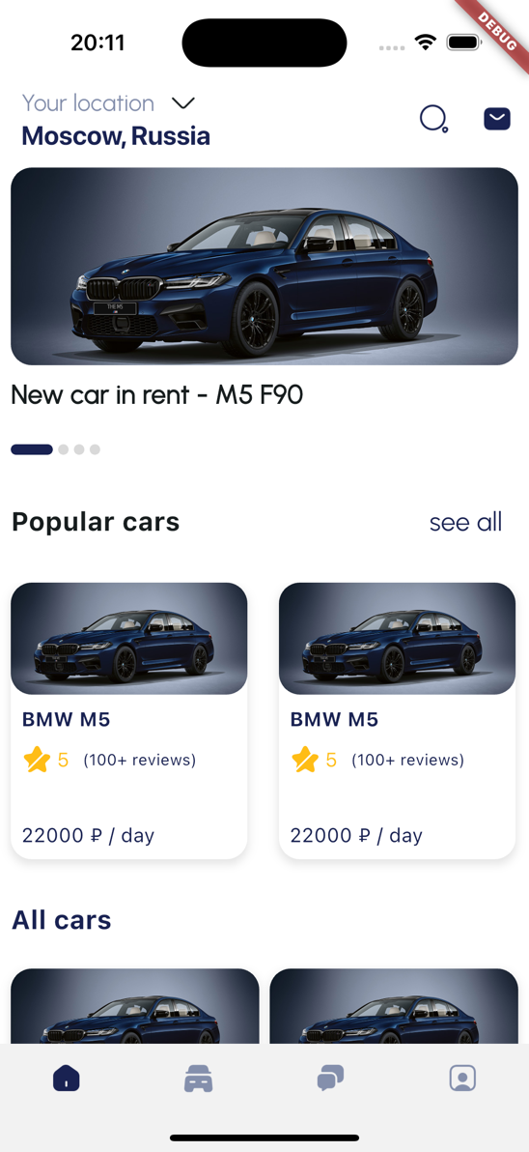

Рисунок 1 – Главный экран в симуляторе iOS

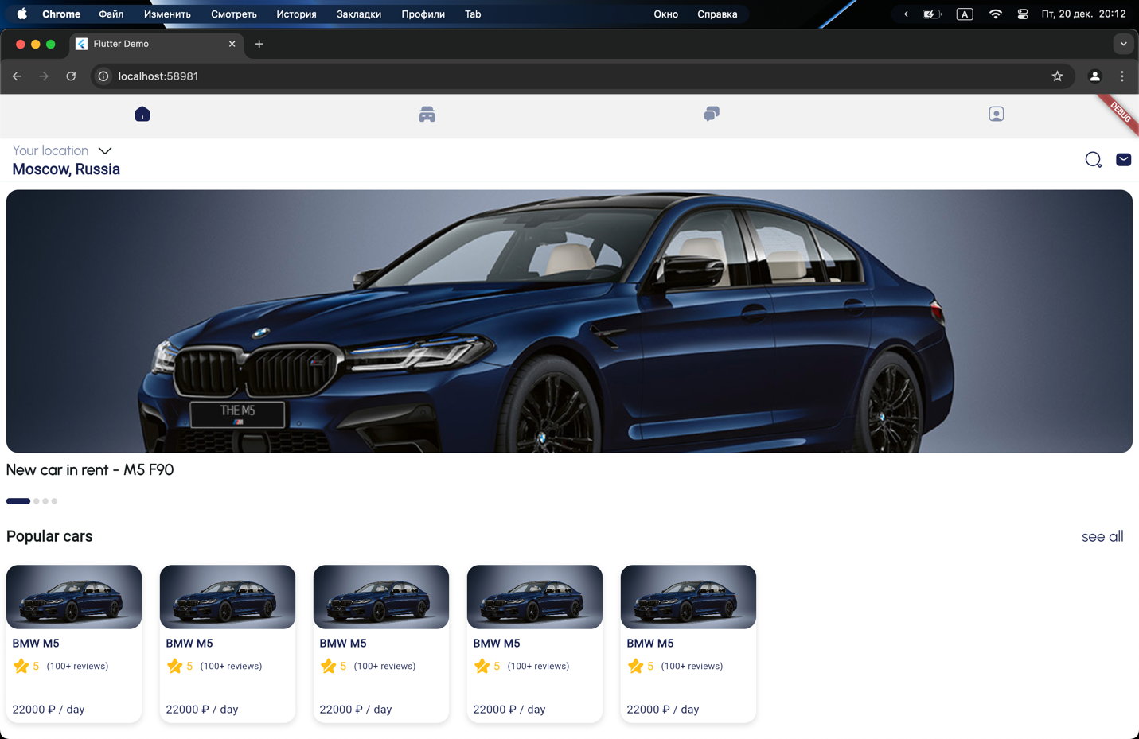

Рисунок 2 – Главный экран в chrome

* 1. **Настройка навигации в DetailPage**

В DetailPage найдем кнопку в SilverAppBar и добавим в обработчик нажатия функцию Navigator.pop(context) – Листинг 15.

Листинг 15 – Кнопка назад

|  |
| --- |
| InkWell(  onTap: () {  Navigator.pop(context);  },  borderRadius: BorderRadius.circular(25),  child: Container(  width: 50,  height: 50,  decoration: const BoxDecoration(  shape: BoxShape.circle,  color: Colors.white,  ),  child: const Center(  child: Icon(  Icons.chevron_left,  size: 30,  color: Color(0xFF192252),  ),  ),  ),  ), |

Листинг 16 – Полный код DetailPage

|  |
| --- |
| import 'package:flutter/material.dart';  import 'package:smooth_page_indicator/smooth_page_indicator.dart';  class DetailPage extends StatefulWidget {  const DetailPage({super.key});  @override  _DetailPageState createState() => _DetailPageState();  }  class _DetailPageState extends State<DetailPage> {  final PageController _pageController = PageController();  double _calculateDynamicHeight(BuildContext context) {  double screenWidth = MediaQuery.of(context).size.width;  if (screenWidth < 400) {  return 200;  } else if (screenWidth > 800) {  return 600;  } else {  return 200 + (screenWidth - 400) * (400 / 400);  }  }  @override  void dispose() {  _pageController.dispose();  super.dispose();  }  @override  Widget build(BuildContext context) {  return Scaffold(  body: Stack(  children: [  CustomScrollView(  slivers: [  SliverAppBar(  automaticallyImplyLeading: false,  leading: Padding(  padding: const EdgeInsets.only(left: 24),  child: InkWell(  onTap: () {  Navigator.pop(context);  },  borderRadius: BorderRadius.circular(25),  child: Container(  width: 50,  height: 50,  decoration: const BoxDecoration(  shape: BoxShape.circle,  color: Colors.white,  ),  child: const Center(  child: Icon(  Icons.chevron_left,  size: 30,  color: Color(0xFF192252),  ),  ),  ),  ),  ),  expandedHeight: _calculateDynamicHeight(context),  floating: false,  pinned: true,  flexibleSpace: LayoutBuilder(  builder: (BuildContext context, BoxConstraints constraints) {  var top = constraints.biggest.height;  return FlexibleSpaceBar(  title: AnimatedOpacity(  opacity: top <= kToolbarHeight + 50 ? 1.0 : 0.0,  duration: const Duration(milliseconds: 300),  ),  background: Stack(  fit: StackFit.expand,  children: [  PageView(  controller: _pageController,  children: [  Image.asset(  'assets/images/bmwm5.jpg',  fit: BoxFit.cover,  ),  Image.asset(  'assets/images/bmwm5.jpg',  fit: BoxFit.cover,  ),  ],  ),  Align(  alignment: Alignment.bottomCenter,  child: Padding(  padding: const EdgeInsets.only(bottom: 16),  child: SmoothPageIndicator(  controller: _pageController,  count: 2,  effect: const ExpandingDotsEffect(  expansionFactor: 4.0,  activeDotColor: Color(0xFF192252),  dotColor: Color(0xFFD9D9D9),  dotHeight: 8,  dotWidth: 8,  spacing: 8.0,  ),  ),  ),  ),  IgnorePointer(  child: Container(  color: Colors.white.withOpacity(  top <= kToolbarHeight + 50 ? 1.0 : 0.0,  ),  ),  ),  ],  ),  );  },  ),  ),  SliverToBoxAdapter(  child: Container(  color: Colors.white,  child: Column(  crossAxisAlignment: CrossAxisAlignment.start,  children: [  Padding(  padding: const EdgeInsets.all(16),  child: Text(  "BMW M5 F90, 2022",  style: const TextStyle(  fontSize: 25,  fontWeight: FontWeight.w900,  color: Color(0xFF192252),  ),  ),  ),  Padding(  padding: const EdgeInsets.symmetric(horizontal: 16),  child: Row(  children: [  const ImageIcon(  AssetImage('assets/images/star.png'),  size: 30,  color: Color(0xFFFFBD16),  ),  Padding(  padding: EdgeInsets.fromLTRB(3, 0, 10, 0),  child: Text(  '5.0',  style: const TextStyle(  fontSize: 20,  color: Color(0xFFFFBD16),  ),  ),  ),  Text(  "(100+ reviews)",  style: const TextStyle(  fontSize: 15,  color: Color(0xFF192252),  ),  ),  ],  ),  ),  Padding(  padding: const EdgeInsets.symmetric(  horizontal: 16, vertical: 20),  child: Text(  "Experience the ultimate combination of luxury, power, and precision with the BMW M5 F90. "  "This high-performance sports sedan features a twin-turbocharged 4.4L V8 engine, delivering an exhilarating 600 horsepower for an unforgettable drive. "  "Equipped with BMW’s signature xDrive all-wheel-drive system, the M5 F90 ensures both stability and thrilling speed in any road condition.\n\n"  "Inside, enjoy a sophisticated, tech-forward interior with premium leather seating, a state-of-the-art infotainment system, and advanced safety features. "  "Whether you’re navigating city streets or taking a weekend getaway, the BMW M5 F90 offers unparalleled comfort and driving dynamics.\n\n"  "Book today and elevate your driving experience with the power and luxury of the M5 F90!",  style: const TextStyle(  fontWeight: FontWeight.normal,  color: Color(0xFF848FAC),  fontSize: 15,  fontFamily: 'Urbanist',  ),  textAlign: TextAlign.start,  ),  ),  Padding(  padding: EdgeInsets.fromLTRB(16, 5, 16, 20),  child: Text(  "CAR INFO",  style: TextStyle(  fontSize: 20,  fontWeight: FontWeight.bold,  color: Color(0xFF192252),  ),  )),  Padding(  padding: const EdgeInsets.fromLTRB(16, 0, 16, 150),  child: Column(  children: [  infoRow(  label: "Engine", value: "4.4L twin-turbo V8"),  const SizedBox(height: 20),  infoRow(label: "Power", value: "600hp"),  const SizedBox(height: 20),  infoRow(label: "Fuel", value: "Casoline"),  const SizedBox(height: 20),  infoRow(label: "Color", value: "Dark Blue"),  const SizedBox(height: 20),  infoRow(  label: 'Drivetrain',  value: "xDrive All-Wheel Drive"),  ],  ),  ),  ],  ),  ),  ),  ],  ),  Positioned(  bottom: 0,  left: 0,  right: 0,  child: Container(  color: Colors.white,  padding: const EdgeInsets.symmetric(horizontal: 16, vertical: 20),  child: Padding(  padding: const EdgeInsets.only(bottom: 16),  child: Row(  mainAxisAlignment: MainAxisAlignment.spaceBetween,  children: [  Column(  crossAxisAlignment: CrossAxisAlignment.start,  children: [  Text(  "BMW M5 F90, 2022",  style: const TextStyle(  fontSize: 20,  fontWeight: FontWeight.bold,  color: Color(0xFF192252),  ),  ),  const SizedBox(height: 8),  Text(  '22 000 ₽ / day',  style: const TextStyle(  fontSize: 15,  color: Color(0xFF192252),  ),  ),  ],  ),  ElevatedButton(  style: ElevatedButton.styleFrom(  backgroundColor: const Color(0xFF192252),  shape: RoundedRectangleBorder(  borderRadius: BorderRadius.circular(10),  ),  ),  onPressed: () {},  child: Padding(  padding:  EdgeInsets.symmetric(vertical: 20, horizontal: 14),  child: Text(  "Rent Car",  style: TextStyle(fontSize: 12, color: Colors.white),  ),  ),  ),  ],  ),  ),  ),  ),  ],  ),  );  }  static Widget infoRow({required String label, required String value}) {  return Row(  mainAxisAlignment: MainAxisAlignment.spaceBetween,  children: [  Text(  label,  style: const TextStyle(  fontSize: 18,  color: Color(0xFF848FAC),  fontWeight: FontWeight.normal,  ),  ),  Text(  value,  style: const TextStyle(  fontSize: 18,  color: Color(0xFF192252),  fontWeight: FontWeight.bold,  ),  ),  ],  );  }  } |

* 1. **Настройка навигации в ProfilePage**

Аналогично HomePage() внесем правки на экран ProfilePage. На кнопки Logout и Delete Account добавим функцию Navigator.pushNamedAndRemoveUntil() – Листинг 17.

Листинг 17 – Кнопки Logout и DeleteAccount

|  |
| --- |
| CustomActionButton(  label: "Log Out",  isPrimary: true,  onTap: () {  Navigator.pushNamedAndRemoveUntil(  context,  '/login',  (Route<dynamic> route) => false,  );  },  ),  const SizedBox(height: 20),  CustomActionButton(  label: "Delete account",  isPrimary: false,  onTap: () {  Navigator.pushNamedAndRemoveUntil(  context,  '/login',  (Route<dynamic> route) => false,  );  },  ), |

Обернем блок с пользовательским фото, именем и иконкой редактирования данных в InkWell и добавим функцию Navigator.pushNamed(context, ‘/editUserPage’) – листинг 18.

Листинг 18 – Обновленный контейнер с информацией о пользователе

|  |
| --- |
| InkWell(  onTap: () {  Navigator.pushNamed(context, '/editUserPage');  },  child: Container(  padding: const EdgeInsets.all(25.0),  decoration: BoxDecoration(  borderRadius: BorderRadius.circular(20),  gradient: const LinearGradient(  colors: [Color(0xFF1B588C), Color(0xFF848FAC)],  begin: Alignment.centerLeft,  end: Alignment.centerRight,  ),  boxShadow: const [  BoxShadow(  color: Colors.black26,  blurRadius: 10,  offset: Offset(0, 4),  )  ],  ),  child: Row(  children: [  ClipOval(  child: SizedBox.fromSize(  size: const Size.fromRadius(24),  child: Image.asset('assets/images/userPhoto.jpg')),  ),  const SizedBox(width: 13),  Text(  'Anna Montana',  style: const TextStyle(  fontSize: 20,  fontWeight: FontWeight.bold,  color: Colors.white,  ),  overflow: TextOverflow.ellipsis,  maxLines: 1,  ),  const Spacer(),  const ImageIcon(  AssetImage('assets/images/edit.png'),  color: Colors.white,  size: 24,  ),  ],  ),  ),  ), |

Листинг 19 – Полный код profile_page.dart

|  |
| --- |
| import 'package:flutter/material.dart';  import '../Components/custom_button.dart';  import '../Components/custom_action_button.dart';  import 'package:flutter/foundation.dart';  import 'dart:io';  class ProfilePage extends StatefulWidget {  const ProfilePage({super.key});  @override  _ProfilePageState createState() => _ProfilePageState();  }  class _ProfilePageState extends State<ProfilePage> {  @override  void initState() {  super.initState();  }  @override  Widget build(BuildContext context) {  bool isMobile = !kIsWeb && (Platform.isAndroid || Platform.isIOS);  Widget content = Column(  children: [  InkWell(  onTap: () {  Navigator.pushNamed(context, '/editUserPage');  },  child: Container(  padding: const EdgeInsets.all(25.0),  decoration: BoxDecoration(  borderRadius: BorderRadius.circular(20),  gradient: const LinearGradient(  colors: [Color(0xFF1B588C), Color(0xFF848FAC)],  begin: Alignment.centerLeft,  end: Alignment.centerRight,  ),  boxShadow: const [  BoxShadow(  color: Colors.black26,  blurRadius: 10,  offset: Offset(0, 4),  )  ],  ),  child: Row(  children: [  ClipOval(  child: SizedBox.fromSize(  size: const Size.fromRadius(24),  child: Image.asset('assets/images/userPhoto.jpg')),  ),  const SizedBox(width: 13),  Text(  'Anna Montana',  style: const TextStyle(  fontSize: 20,  fontWeight: FontWeight.bold,  color: Colors.white,  ),  overflow: TextOverflow.ellipsis,  maxLines: 1,  ),  const Spacer(),  const ImageIcon(  AssetImage('assets/images/edit.png'),  color: Colors.white,  size: 24,  ),  ],  ),  ),  ),  const SizedBox(height: 30),  CustomButton(  iconPath: 'assets/images/lock-circle.png',  label: "Change password",  onTap: () {},  ),  const SizedBox(height: 21),  CustomButton(  iconPath: 'assets/images/empty-wallet.png',  label: "Billing information",  onTap: () {},  ),  const SizedBox(height: 21),  CustomButton(  iconPath: 'assets/images/direct-inbox.png',  label: "Notifications",  onTap: () {},  ),  isMobile ? const Spacer() : const SizedBox(height: 250),  CustomActionButton(  label: "Log Out",  isPrimary: true,  onTap: () {  Navigator.pushNamedAndRemoveUntil(  context,  '/login',  (Route<dynamic> route) => false,  );  },  ),  const SizedBox(height: 20),  CustomActionButton(  label: "Delete account",  isPrimary: false,  onTap: () {  Navigator.pushNamedAndRemoveUntil(  context,  '/login',  (Route<dynamic> route) => false,  );  },  ),  isMobile ? const SizedBox(height: 100) : const SizedBox(height: 0)  ],  );  return Scaffold(  body: Stack(  children: [  Positioned.fill(  top: 117,  left: 0,  right: 0,  bottom: 0,  child: Container(  color: Colors.white,  child: Padding(  padding: const EdgeInsets.symmetric(horizontal: 16.0),  child: isMobile  ? content  : SingleChildScrollView(  child: content,  ),  ),  ),  ),  Positioned(  top: isMobile ? 0 : 59,  left: 0,  right: 0,  child: AppBar(  backgroundColor: Colors.white,  elevation: 0,  title: Text(  "Profile",  style: TextStyle(  color: Color(0xFF192252),  fontSize: 25,  fontWeight: FontWeight.bold,  ),  ),  centerTitle: false,  ),  )  ],  ),  );  }  } |

На рисунках 3 и 4 представлен внешний вид экрана профиля после внесенных изменений на мобильном устройстве и в chrome.

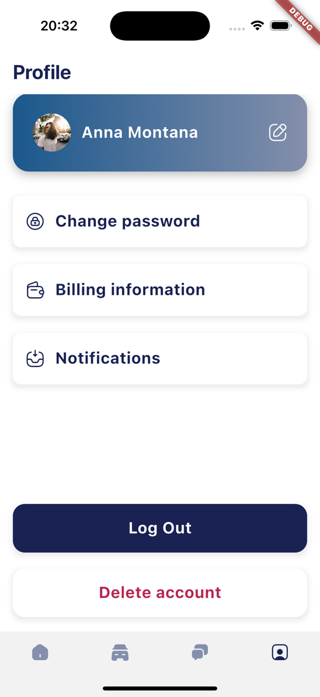

Рисунок 3 –Экран профиля в симуляторе iOS

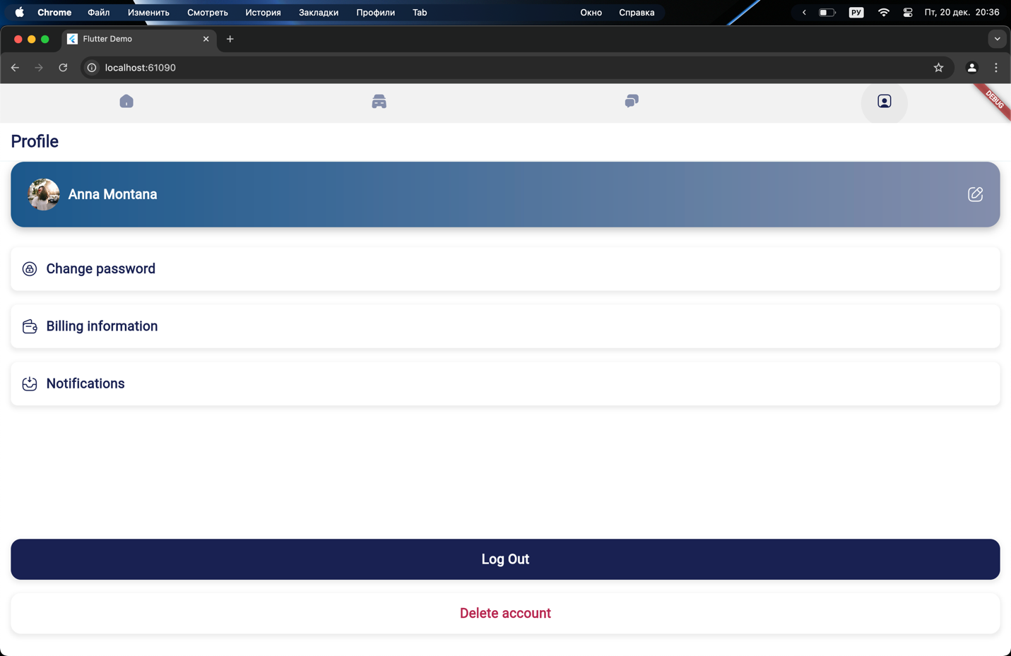

Рисунок 4 – Экран профиля в chrome

* 1. **Настройка навигации в EditUserPage**

На экране EditUserPage добавим на кнопку назад функцию Navigator.pop(context) – листинг 20.

Листинг 20 – Кнопка назад

|  |
| --- |
| IconButton(  icon: Image.asset('assets/images/backIcon.png'),  onPressed: () {  Navigator.pop(context);  },  ), |

Листинг 21 – полный код экрана EditUserPage

|  |
| --- |
| import 'dart:io';  import 'package:flutter/material.dart';  import '../Components/text_field.dart';  import '../Components/custom_action_button.dart';  import 'package:flutter/foundation.dart';  class EditUserPage extends StatefulWidget {  const EditUserPage({super.key});  @override  _EditUserPageState createState() => _EditUserPageState();  }  class _EditUserPageState extends State<EditUserPage> {  @override  void initState() {  super.initState();  }  @override  void dispose() {  super.dispose();  }  @override  Widget build(BuildContext context) {  bool isMobile = !kIsWeb && (Platform.isAndroid || Platform.isIOS);  var content = Padding(  padding: const EdgeInsets.symmetric(vertical: 8, horizontal: 24),  child: Column(  children: [  Align(  alignment: Alignment.centerLeft,  child: Text(  "Update user info",  style: TextStyle(  fontWeight: FontWeight.bold,  fontSize: 25,  color: Color(0xFF192252),  ),  ),  ),  const SizedBox(height: 20),  Container(  width: 130,  height: 130,  decoration: BoxDecoration(  borderRadius: BorderRadius.circular(24),  image: const DecorationImage(  image: AssetImage(  'assets/images/userPhoto.jpg'),  fit: BoxFit.cover,  ),  ),  child: Center(  child: Icon(  Icons.camera_alt,  color: Colors.white.withOpacity(0.7),  size: 50,  ),  ),  ),  const SizedBox(height: 35),  CustomTextField(  labelText: "Full name",  initialText: "Enter your name",  ),  const SizedBox(height: 25),  CustomTextField(  labelText: "Email address",  initialText: "Enter your email",  ),  isMobile ? const Spacer() : SizedBox(height: 220),  CustomActionButton(  label: "Update info",  isPrimary: true,  onTap: () {},  ),  const SizedBox(height: 55),  ],  ),  );  return Scaffold(  appBar: AppBar(  backgroundColor: Colors.white,  elevation: 0,  automaticallyImplyLeading: false,  title: Row(  crossAxisAlignment: CrossAxisAlignment.start,  children: [  SizedBox(  width: 50,  height: 50,  child: IconButton(  icon: Image.asset('assets/images/backIcon.png'),  onPressed: () {  Navigator.pop(context);  },  ),  ),  ],  ),  ),  backgroundColor: Colors.white,  body: isMobile ? content : SingleChildScrollView(child: content),  );  }  } |